**Work-Case №1**

**Коваль Олексій**

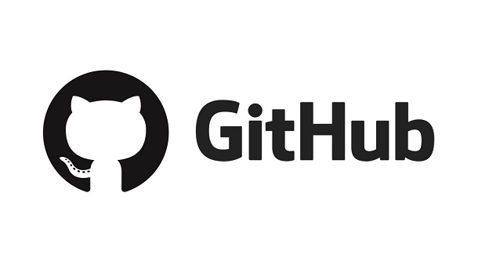

**Git- is software for tracking changes in any set of files, usually used for coordinating work among programmers collaboratively developing source code during software development. Its goals include speed, data integrity, and support for distributed, non-linear workflows (thousands of parallel branches running on different systems)**

**Git was created by Linus Torvalds in 2005 for development of the Linux kernel, with other kernel developers contributing to its initial development. Since 2005, Junio Hamano has been the core maintainer. As with most other distributed version control systems, and unlike most client–server systems, every Git directory on every computer is a full-fledged repository with complete history and full version-tracking abilities, independent of network access or a central server. Git is free and open-source software distributed under GNU General Public License Version 2.**

**Git is a set of command line utilities that allow you to track and record changes to files (usually code, but you can track anything). With it, you can restore old versions of your project, compare, analyze, combine changes and more. This process is called version control. There are many similar version control systems. You may have heard some of them: SVN, Mercurial, Perforce, CVS, Bitkeeper and others.**

**Git works decentrally, which means it is independent of the central server. The data is stored locally in a folder on your hard drive called a repository. However, you can also save a copy of your repository online, allowing a team of people to work on a single code at a time. Sites such as GitHub and BitBucket are used for this purpose.**

**Github service is an effective tool for teamwork**

**on the web-product development project. Possession of skills of use**

**service allows web-developer to work more efficiently with sites. Yes**

**competence is a requirement of employers for modern web-product developers.** 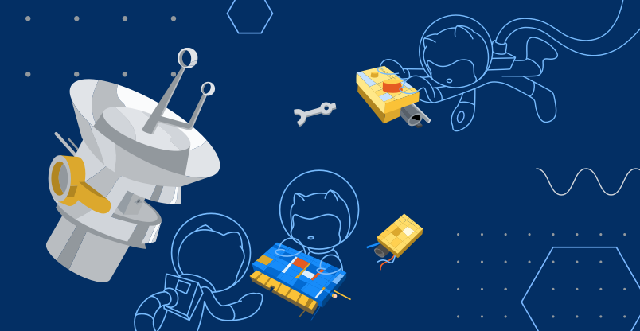

**Git is one of the most efficient, reliable and high-performance systems**

**version control, which provides flexible non-linear development tools based**

**on the branch and merging of branches. To ensure the integrity of history and sustainability**

**to changes in retrospect cryptographic methods are used, it is possible**

**linking digital signatures of developers to tags and committees.**

**The system is designed as a set of programs specifically designed with**

**given their use in scripts. This makes it easy to create**

**specialized version control systems based on Git. For example, Cogito is**

**just such an example of a frontend to Git repositories. And StGit uses Git**

**to manage a collection of patches.**

**The system has a number of interfaces: for example, gitk and git-gui.**

**Remote access to Git repositories is provided by a git daemon, SSH**

**or HTTP server. TCP service git-daemon is part of the Git distribution and is together**

**with SSH the most common and reliable method of access. HTTP access method,**

**despite a number of limitations, very popular in controlled networks,**

**because it allows the use of existing network filter configurations.**

